**Finalized Testing Plan**

**Poba Medical Capstone Team**

**03/25/2022**

**Design Requirements Summary**

**Customer Requirements**

1. Test Expanded Extrusion Diameters
   1. The Purpose of the radial expansion tester is to test the expansion of a plastic extrusion when heated, pressurized, and stretched. Therefore, measuring the final radius will be essential.
2. Temperature Control for Extrusion
   1. In order for the plastic extrusion to expand, the team will need to heat the extrusion. Therefore, it will be necessary to control the temperature of the extrusion.
3. Actuate axial force
   1. In order to create expansion in the extrusion, the extrusion needs to be stretched after being heated and pressurized. Therefore, the team will need to have a system that can create enough axial force in a small enough time to trigger expansion.
4. Pressurize Balloons During Testing
   1. In order to trigger Expansion, the balloon will need to be pressurized. Therefore, it will be necessary for the team to have a system to supply sufficient pressure.
5. Stay Within Budget
   1. The engineers at Poba Medical have requested that the team stays within a budget of $10,000.
6. Complex and Robust design
   1. Dr Willy has requested that the team creates a complex and robust design. This means that the design needs to be sufficiently reliable, as well as have working subsystems.

**Engineering Requirements**

1. Apply a Maximum of 150 lbf of Axial Force
   1. The engineers have specifically requested that the team creates a system that will be able to supply up to 150 lbf of axial force. This should be enough for around 95% of their stock.
2. Expand diameter .2-2.5”
   1. The engineers at Poba have requested that the team create a machine that can expand extrusions up to 2.5 inches in diameter.
3. Control Temperature up to 250 °F
   1. The engineers at Poba have requested that the team creates a system that can heat extrusions up to 250 °F
4. Measure Test Diameter .2-2.5”
   1. The engineers at Poba have requested that the team designs a system that can measure the diameter of extrusions ranging from .2-2.5”.
5. Measure Temperatures up to 250 °F
   1. The engineers at POBA have requested that the team is able to measure how the extrusion or the air directly surrounding the extrusion is.
6. Pressurize Balloons up to 300 psi
   1. The team
7. Output measurements In Easy to Read Format
   1. The team will need to output all of the measurements that have been taken (extrusion diameter, temperature,pressure) in an easy to read way.

**Top Level Testing Summary**

The three most important subsystems which will be necessary to test were determined to be the systems associated with the micrometer reliability, temperature output, and linear force. These systems are vital to the successful function of the machine as they are all required to be in proper working order to get usable data about how different extrusion sizes and materials behave under different conditions. As such, three tests are proposed in order to confirm that each of these operate effectively as described in the table below.

*Table 1: Test Summary Table*

| Tests | Design Requirement |
| --- | --- |
| Micrometer Repeatability test | CR1, ER2, ER4, ER7 (Measure extrusion diameters) |
| Temperature Output test | CR2, ER3 (Confirms reliability of heating system) |
| Linear Force Test | CR3, ER1 (Confirms system is capable of actuating with required amount of force) |

**Detailed Testing Plans**

**Temperature Output Test**

Since the system is required to heat the extrusions to a maximum temperature of 250°F, the team must evaluate the heating system in order to confirm that it is able to reach this temperature in a safe and controlled manner. The two most relevant variables impacting the temperature output of the heater will be the airflow rate and the temperature setting on the temperature controller. For clarity, a diagram of the heating system is included below. Air from a compressor is fed through an airflow meter connected to a “duct heater” containing a resistive heating element which will heat this air before it is diverted through a custom made “heater nozzle”. Temperature control is provided by a thermocouple located at the outlet of the heater connected to a Watlow temperature controller which varies the input voltage to the heater in order to raise or lower the operating temperature.

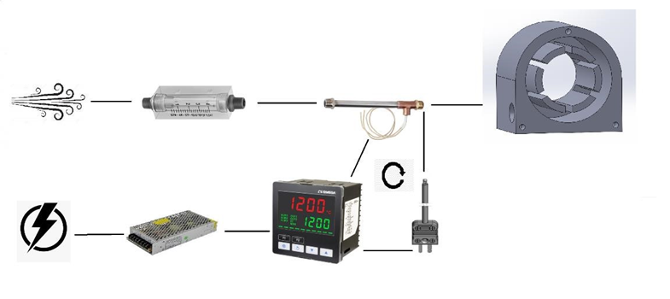

Fig 1: “Heating System”

The temperature set at the temperature controller and the airflow set manually will be the two most impactful variables in the output temperature. A test of these two variables will be conducted which require that the system be run at multiple different temperature and airflow settings to observe if any major differences exist between each of these. A table proposing how each relevant variable will be isolated is attached below. The team will first begin by setting the temperature controller to a set temperature and then observing how varying the airflow will impact how long it takes for the system to reach this temperature at multiple different locations. If the system is unable to meet the required temperature at any of the proposed locations this will be noted and an adjustment to the temperature controller setting will be made accordingly.

*Table 2: Heating system test with variable air flow*

| Air Flow **(CFM)** | Temperature on Temp Controller (°F) | Time to Temp at Duct Heater Outlet | Time to Temp at Heater Nozzle | Time to Temp  Inside Extrusion |
| --- | --- | --- | --- | --- |
| 1 | 200 |  |  |  |
| 2 | 200 |  |  |  |
| 3 | 200 |  |  |  |

*Table 3: Heating system test with variable temperature*

| Air Flow **(CFM)** | Temperature on Temp Controller (°F) | Time to Temp at Duct Heater Outlet | Time to Temp at Heater Nozzle | Time to Temp  Inside Extrusion |
| --- | --- | --- | --- | --- |
| 2 | 100 |  |  |  |
| 2 | 200 |  |  |  |
| 2 | 300 |  |  |  |

While not entirely necessary, it would be advisable to calculate the estimated pressure drop across the duct heater in order to estimate the effective outlet flow at the heater nozzle as well as the empirically-found thermal diffusivity of a given extrusion size so that future estimations about how long to heat a given size extrusion can be made by the clients.

Procedure

First, all electrical connections will be checked and the system will be powered on. An air supply will be connected and leaks will be looked for. Second, the flowrate will be switched on and set to its associated value as it is stipulated in the manual that the duct heater should not be operated without airflow. Third, the temperature controller will be turned on and set to the required temperature. At the same time, a stopwatch will be started. Next, the team will monitor the temperature on the associated thermocouples and visually check that all components do not appear to be excessively hot or that components are not melting or changing in any observable way. In addition to a constant visual check, a handheld IR gun will be used to monitor the temperature of all associated components to record their temperatures as well. Once the temperatures all appear to be at a steady state, the time to achieve them will be recorded and the heater will be powered off. The flowing air will be allowed to continue running through the system to cool everything back to baseline temperature before repeating this procedure for each subsequent trial run.

Results

It is expected that the temperature seen at the outlet of the heater which is controlled by a thermocouple will be the first to display the desired temperature. The two additional locations at the outlet of the heater and the interior of an extrusion will most likely be much slower to reach thermal equilibrium as there are more associated components in series which will work to slow the heat transfer like the airline to the nozzle, the nozzle itself and the material of the extrusion. The equation governing the temperature reached by a solid at a given time can be expressed by:

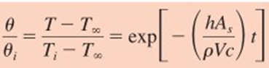 (1)

It is estimated that it will take roughly 2 minutes to reach a 100°F thermal equilibrium, 5min to reach 200°F, and 7min to reach 250°F.

Conclusion

Knowing the relationship between airflow, Watlow temperature setting, and time required to reach this temperature will be vital to the clients future testing processes as the data gathered from these tests will allow them to extrapolate out to any number of different size extrusion diameters. A meticulous evaluation of this system will be performed in the NAU thermal sciences laboratory for completion of the ME495 design project. Calculated results from data gathered during this experiment will be included in the operations manual which will be created by the team to give to the clients which detail the settings and results of any combination of potential conditions the machine could be used under.

**Micrometer Repeatability Test**

The primary purpose of the device is to measure the expansion of plastic extrusions. To do this, the team needs to make sure that the micrometer is accurate in its measurements and will reliably measure the correct section of the extrusion as it expands. First, to ensure the accuracy of the measurements, the micrometer will be calibrated using gauge blocks. Once calibrated, the team will perform repeated measurements on an assortment of objects to determine the precision of the micrometer in practice.

*Table 4: Micrometer precision data*

| Object | Run 1 | Run 2 | Run 3 | Run 4 | Run 5 | Avg | Std Dev |
| --- | --- | --- | --- | --- | --- | --- | --- |
| 1 |  |  |  |  |  |  |  |
| 2 |  |  |  |  |  |  |  |
| 3 |  |  |  |  |  |  |  |

Next, the team will test how reliably the micrometer measures the correct section of the extrusion. This is relevant because the micrometer is moved into location by an air cylinder before it takes measurements. If moved to the wrong location, the micrometer will not measure the point of greatest expansion on the extrusion. For this test, the team will have to heat, stretch, inflate, and attempt to measure several extrusions. The data recorded in this test will be what side of the measurement window maximum expansion occurred on, and how far the point of max expansion is from the centerline of the measurement window. From this data, the team will be able to determine how much the mounting needs altered in order to make sure that extrusions expand near the center of the micrometer’s measurement window.

*Table 5: Micrometer positioning data*

|  | Run 1 | Run 2 | Run 3 | Run 4 | Run 5 |
| --- | --- | --- | --- | --- | --- |
| Side: L or R |  |  |  |  |  |
| Distance from Centerline |  |  |  |  |  |

Results

The team fully expects that the micrometer will always meet the requirement of measuring within one thousandth of an inch of the true diameter of the extrusions. This is because the resolution of the micrometer is 0.5*10-5 mm. It is also expected that some minor adjustment will have to be made to the mounting of the micrometer. Currently, the system is set up so that the micrometer is moved roughly to the center of the heated section of the extrusion, but only testing will show exactly where the extrusions tend to expand within the measurement window.

Conclusion

Two things are necessary in order to meet the requirements of the measurement system: measurements taken must be accurate, and the location measured must be the point of maximum expansion. By performing these tests, the clients will be able to have confidence that their results will be accurate to a satisfactory degree. The results of these tests will be included in the operations manual so that the clients may understand the reliability of their measurements.

**Linear Force Test**

Introduction

In order to create a machine that can successfully blow and measure medical balloons, the team will need to ensure they can reliably apply up to 150 lbf of axial force. This is being done using a ball screw-stepper motor set up. The team has done many preliminary calculations to ensure that the motor will be able to supply enough torque for the system to actuate well over 150 lbf of axial force. However, these calculations do not account for things like the friction of the flange against the baseplate, the eccentricity of the screw, or other frictional causes due to tolerance stack-up. Because of this, the team will need to test the axial force system to ensure that the system can supply up to 150 lbf of axial force.

Theory

The team will test this system by taking advantage of Hooke’s Law. Hooke’s states that the force generated by a spring is equivalent to the following equation.

$F_{s}= -kx$ (2)

Where k is a spring constant, x is the amount the spring is deformed from its unstretched length, and Fs is the force due to the spring. If the team creates an axial force using the ball screw motor setup, it should be able to stretch a spring some amount based on equation 1. This amount can be found by creating a free body diagram around a system containing the axial force actuator and a spring. This Free body diagram can be found below.

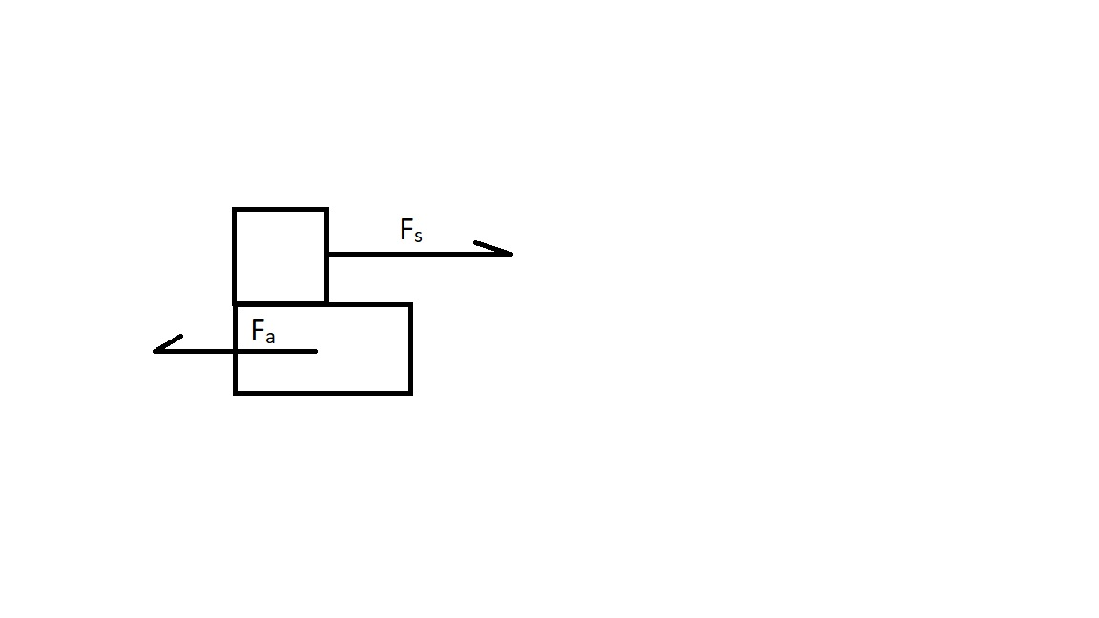

*Figure 2: Primitive FBD of Axial Force Actuator*

Where Fs is the force due to the spring and Fa is the force due to the actuator. Solving Newton's Second Law for a system in equilibrium, gives us the following equation.

$F_{a}=F_{s_{}}$ (3)

Where Fa is the force due to the actuator and Fs is the force due to the spring. Fs can then be replaced with -kx, and we can find Fa using the following equation.

$F_{s}=kx$ (4)

The team can calculate the k constant using known weights, and then measure the deformation due to the actuator to calculate the force due to the actuator. This will give an empirical way to ensure that we are supplying up to 150 lbf of axial force even with unaccounted sources of friction.

Procedure

The team will first need to calculate the spring constant k. This will be done by measuring the deformation of the spring due to 5 different weights ranging from 30-150 lbf and calculating the spring constant by solving eq 1. These values will then be recorded in the following table.

*Table 6: Spring Calibration Table*

| Weight (lbf) | Deformation (in) | Calculated k Value |
| --- | --- | --- |
| 30 |  |  |
| 60 |  |  |
| 90 |  |  |
| 120 |  |  |
| 150 |  |  |

In order to accomplish this, the team will attach the spring to a secure location, and then attach the weight to the spring. The deformation will then be calculated by subtracting the final length of the spring from the initial length of the spring. The team will then calculate the average k, along with the uncertainty of the k calculated.

The team will then attach the spring to the pneumatic clamp being driven by the motor, and another secure location. The motor will be run at a variety of speeds, ranging from 1-10 based on the location of the potentiometer. The team will record the data in the following table. Calculated Force will be calculated using equation 3, where k will be the average k calculated in the previous step.

*Table 7: Linear Actuator Calibration Table*

| Deformation (In) | Speed (1-10) | Calculated Force (lbf) |
| --- | --- | --- |
|  |  |  |
|  |  |  |
|  |  |  |

Conclusion

In order to create a linear actuation system worthy of our investors, our linear actuation system needs to be able to actuate up to 150 lbf of axial force. This will be measured by taking advantage of hooke's law. The team will calculate the spring constant of a spring, and then use that same spring to calculate the axial force being supplied by the spring.

**Specification Sheet Preparation**

The table below documents whether or not each customer requirement has been met by the end of the project and whether or not the client has approved the success of each requirement. This will give a defined checklist to establish that, not only did we achieve what the team set out to do with this project, but that the clients are also satisfied with the solutions presented by the team.

*Table 8: CR Summary Table*

| **Customer Requirement** | **CR met? (Y or N)** | **Client Acceptable? (Y or N)** |
| --- | --- | --- |
| Test Expanded Extrusion Diameters |  |  |
| Temperature Control for Extrusion |  |  |
| Actuate axial force |  |  |
| Pressurize Balloons During Testing |  |  |
| Stay Within Budget |  |  |
| Complex and Robust design |  |  |

Since some of the engineering requirements defined previously may have some variation in what could be considered acceptable, an adequate target range and tolerance has been given to each relevant requirement. In addition to this, if this requirement was confirmed by calculations or by measurement will also be designated along with a confirmation from the clients that they have accepted that this has been accomplished.

*Table 9: ER Summary Table*

| **Engineering Requirement** | **Target** | **Tolerance** | **Measured/ Calculated Value** | **ER met?**  **(Y or N)** | **Client Acceptable**  **(Y or N)** |
| --- | --- | --- | --- | --- | --- |
| Apply a Maximum of 150 lbf of Axial Force | 0-150 | N/a | Calculated |  |  |
| Expand diameter 0.2-2.5” | 0.2-2.5” | N/a | Measured |  |  |
| Control Temperature up to 250°F | 50-250°F | +/- 10°F | Measured |  |  |
| Measure Test Diameter 0.2-2.5” | 0.2-2.5” | 0.005” | Measured |  |  |
| Measure Temperatures up to 250 °F | 50-250°F | +/- 1°F | Calculated |  |  |
| Pressurize Balloons up to 300 psi | 0-300psi | N/a | Measured |  |  |
| Output measurements In Easy to Read Format | Computer output | Y/N | Measured |  |  |

**QFD**

The tested engineering requirements relate to all of our customer requirements. The Temperature Output Test related to CR 2 and ERs 3 and 4. This is because these are the customer and engineering requirements that relate to ensuring that the extrusion is properly heated. The micrometer repeatability test relates to CR 3 and ER1, ER4, and ER7. This is because this is testing the system to properly measure extrusion diameters, which is arguably the most important part of the project. The Linear Force Test will test CE3 and ER1, which are the engineering and customer requirements relating to actuating linear force. Along with this, it could be argued that all of these relate to CR2, ER2 and ER4, as in order to have a balloon expand and measured we need to have all of the systems working at once. To help visualize this, the team’s QFD has been included below.

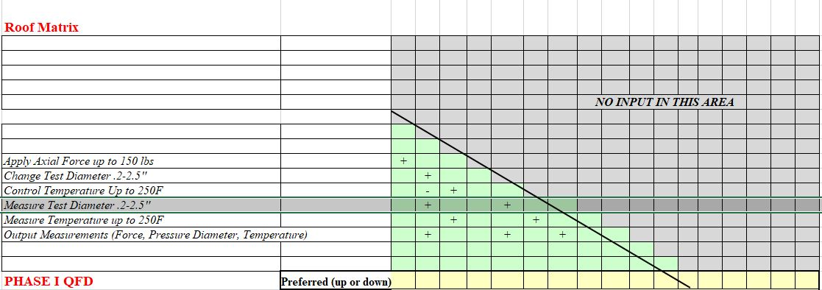

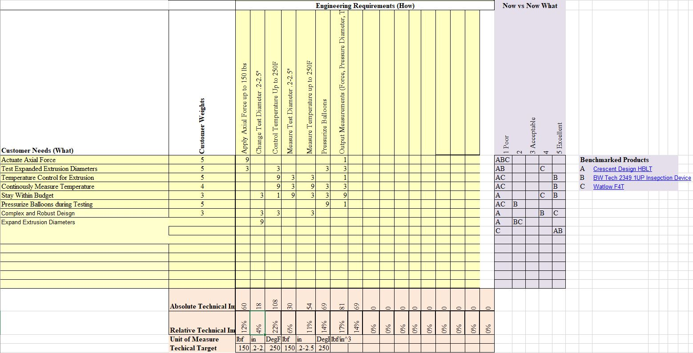

*Figure 2: QFD*

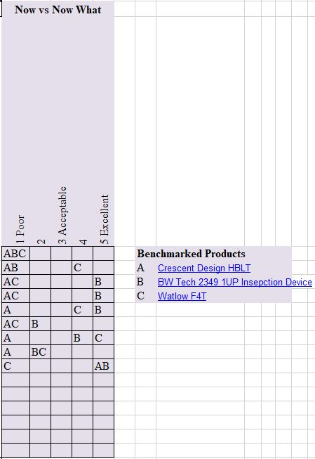

*Figure 3: QFD Benchmarking*